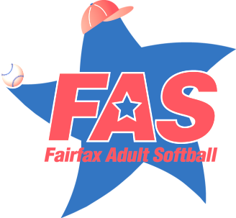

[www.fairfaxadultsoftball.com](http://www.fairfaxadultsoftball.com)

***A 501c3 Charitable Organization***

**Fairfax Adult Softball Honors President with Volunteer of the Year Award**

Fairfax County -- Fairfax Adult Softball (FAS), the largest adult ASA softball league in the country, celebrated the spirit of altruism and selfless-service at PJ Skidoos in Fairfax, Virginia, on Friday, February 6th.

“We run the largest adult ASA softball league in the United States,” said Christine Idip, FAS Program Administrator, “and we couldn’t do that without our amazing, dedicated volunteers. All of them love the game of softball and are willing to put in extra hours to make sure the spirit of the game is kept alive!”

League Vice President, Scott Semmler, recognized John Carney as the 2014 “Ron Bullock Volunteer of the Year.” Since accepting the position of President over 10 years ago, John has worked diligently to ensure FAS remains the largest and most organized ASA softball program in the nation.

Humbly, Carney said “if it wasn’t for the amazing people surrounding me, I would not be able to continue the great work that has made this organization so successful.” He went on to say that “2014 was a tough year but it’s rewarding to know the volunteers and new staff have persevered and I am looking forward to the new ideas coming forth in 2015.”

The “Ron Bullock Volunteer of the Year” award was created to recognize individuals who make a substantial commitment to volunteering and improving the FAS program. This award is given to those that demonstrate outstanding volunteer service over the course of 12 months.

Along with the Volunteer of the Year award, we also honored our 2014 Hall of Fame inductees. Four volunteers and a team were introduced by members of the FAS family and presented awards for their dedication to the program. Inductees, staff and members of the FAS Board of Directors and their family members enjoyed a plated dinner and dessert while taking part in this annual event!

“FAS is the largest and best run league in America because of our volunteers.” said John Carney, President of FAS. “The volunteer recognition banquet is the most rewarding event on our annual calendar.”