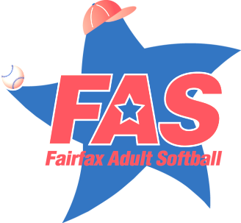

[www.fairfaxadultsoftball.com](http://www.fairfaxadultsoftball.com)

***A 501c3 Charitable Organization***

**PRESS RELEASE**

DATE**:** January 27, 2015

**FOR IMMEDIATE RELEASE**

ORGANIZATION: Fairfax Adult Softball, Inc.

CONTACT: Rebecca Frece

NUMBER: 703-815-9007

**FAIRFAX ADULT SOFTBALL HOSTS 15TH ANNUAL BOWLING BENEFIT IN SUPPORT OF SPECIAL OLYMPICS**

*THOUSANDS RAISED TO HELP THE AMAZING ATHLETES*

**Photo Caption:** Northern Virginia Special Olympians after receiving their medals! Pictured: Shannon McAvoy, Michael Barber, Alexis Gillette, Kevin Leddy and Kyle Leddy.

Participants, friends and long-time supporters of Fairfax Adult Softball, Inc. (FAS) united together on Sunday, January 25th for the 15th Annual Benefit Bowling Tournament to raise funds for Northern Virginia Special Olympics and Fairfax County Park Authority field improvements. Over 250 players and volunteers came out to the Bowl America in Falls Church, and participated in the event which raises over $15,000 each year**.**

Returning to the event was Kevin Ogletree, Special Olympics Global Messenger, who presented the opening ceremony speech. FAS Program Administrator, Christine Idip says, “Kevin has been an event favorite every year with his inspiring and enthusiastic message!” She goes on to say, “The tournament is always the highlight of my year because it’s all about having fun while giving back to the community. I enjoy developing new ways to make this event a success for such a great cause and I am honored to be a part of the FAS fundraising legacy.”

FAS President, John Carney, who has volunteered at the event for years, agrees with Christine whole heartedly. He said, “Each year, I am astonished at not only the commitment of our community but their generosity and kind hearts. Every year, I think the event can’t get better but every year, I’m proved wrong. On behalf of the organization as a whole, thank you to all who helped, donated, participated, and sponsored this year's Benefit.”

FAS’s bowling commitment started 15 years ago however; we have been special partners with Special Olympics since 1988 when FAS was approached by Eunice Kennedy Shriver to assist in establishing a pilot program where Special Olympians play softball alongside our volunteers. Hundreds of Special Olympians have gained not only the enjoyment of competitive sports, but also the camaraderie, training and health benefits that only sports can offer.

Interested in becoming a part of this great program? Come experience first-hand the enjoyment that only FAS softball offers. We offer play for adult men and women in a number of different leagues across Fairfax County: Men, Women, Coed, Women’s Fast Pitch, Men’s 35+, Men’s 50+ and Church. REGISTRATION IS CURRENTLY OPEN for our 2015 Spring Season. The deadline for team applications and payments is March 6, 2015. Visit us and register online today at: [www.fairfaxadultsoftball.com](http://www.fairfaxadultsoftball.com)